CU RoboSub Team

8/15/2018

Backplane V3

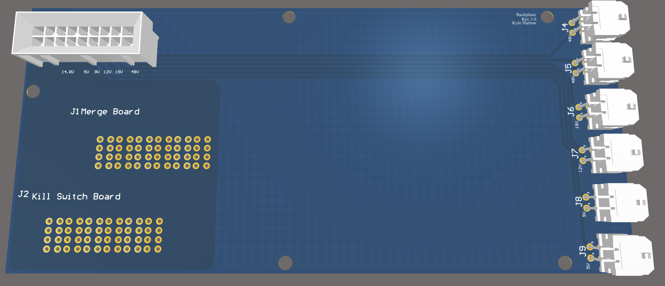

**Abstract** **3**

**Design Requirements** **3**

**Design Overview** **3**

Previous designs 3

**System descriptions** **4**

**System status** **4**

**Known Issues** **4**

**Appendix** **5**

# 

# Abstract

The backplane supports all of the other PCBs attached to it and properly routes power to those boards. The backplane also routes power to all other systems on the sub through a variety of headers and passive components.

# Design Requirements

Using a variety of molex connectors, passive traces, and polygon planes, the backplane must:

* Receive input power and ground connections from the merge board.
* Route proper connections for power and ground to every other board without thermal issues.
* Export the power board’s voltage lines to an accessible place in the sub, so wires can be routed to proper locations.

# Design Overview

This entirely passive board will use molex connectors and heavier copper pours to achieve all design requirements listed above. The Merge Board and ESC Board will connect using Molex’s EXTreme EnergetiC Modular Right-Angle and Vertical Plug Assemblies since they only need to pass a lot of power between each other. The Power Board will connect to the backplane through Molex’s Micro-Fit BMI Dual Row Receptacle Header with 18 pins because it has to pass several voltage lines as well as receive enough power and ground connections for proper power delivery. For the conversion from PCB traces to wires, we used the 4 pin Molex MiniFit Juniors at the end of the power board. Despite their size, these can handle the current requirements our systems need, and with their locking clips, they provide safe connections to the rest of the system.

## Previous designs

Previous designs of the backplane had no major issues, but the change to better connectors required a redesign. This redesign also allowed us to switch to higher oz copper which was a long term plan to allow for better thermals.

# System descriptions

Shown below is the completed backplane in Altium. Red represents top layer traces while blue represents bottom level traces. To properly route power without overheating, this board was manufactured with 6oz copper, which physically compresses more copper onto the pcb traces and planes so it takes longer to heat up. This increase of copper allows for smaller trace widths from the power board connector, at the top of the picture, to the molex connectors, at the far right of the picture.

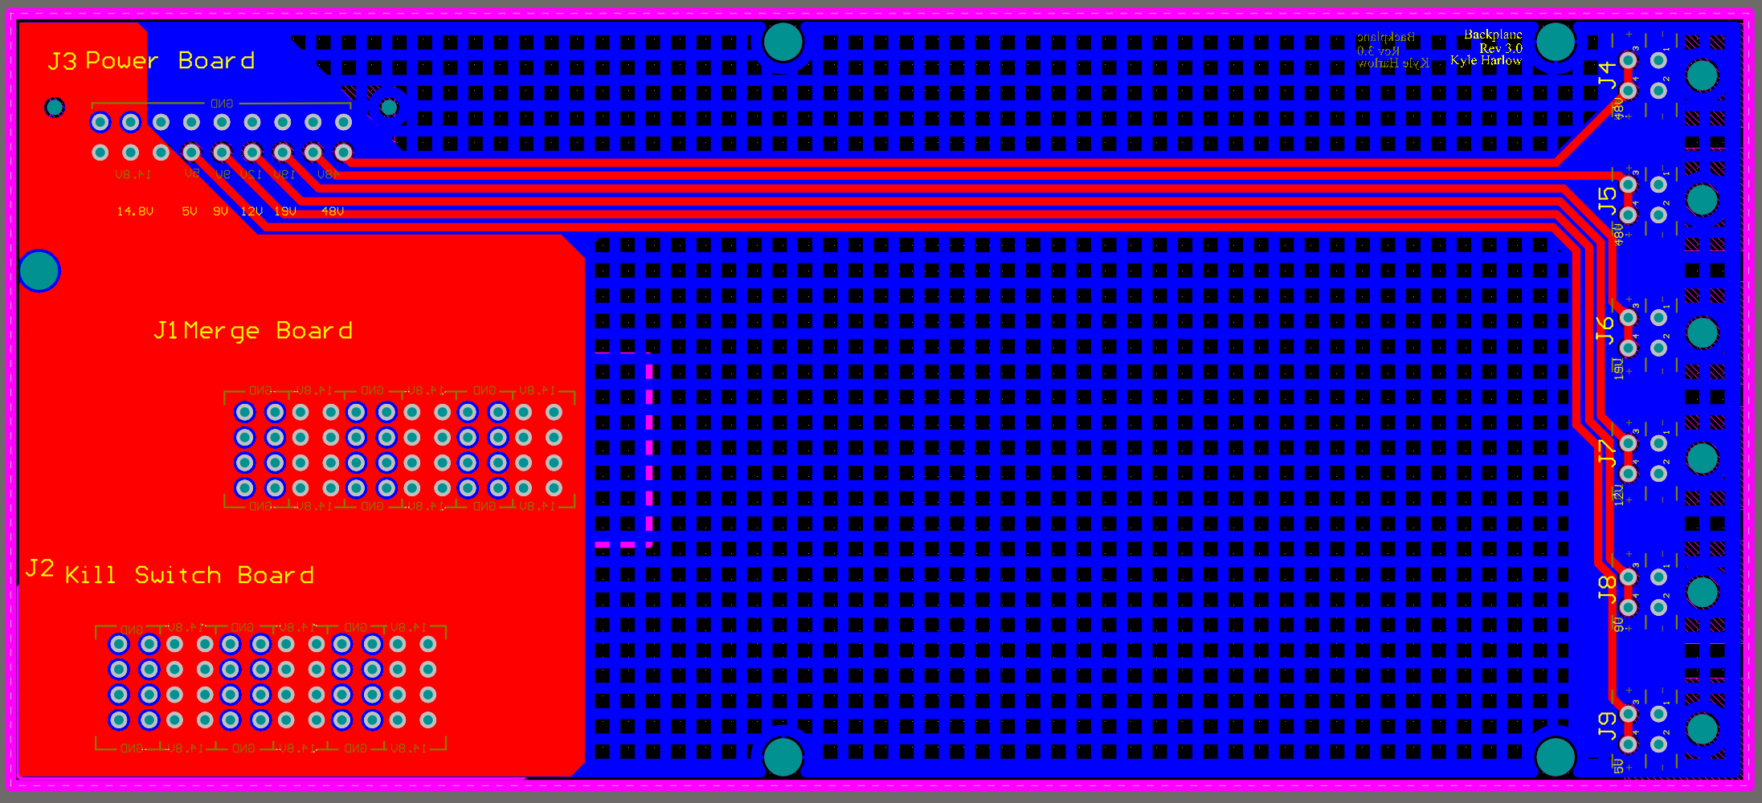

Due to this board being entirely passive and still quite large, the ground plane, on the bottom layer, was latticed in unused areas. This reduces the amount of wasted copper while still providing proper connections, resistance from warping, and some noise shielding. Besides the molex vias, full standoff screw holes were created for proper usage in the sub on the electrical rack. This was mainly for support and rigidity since none of the electrical rack was conductive.

# System status

This system was completed and ran successfully on the 2018 sub Leviathan. No major issues were experienced after soldering.

# Known Issues

* Board potentially not needed. If kill switch/esc board is removed, the molex connectors can be moved to the power and merge boards to save cost and space. The power and merge boards can then be directly connected to transfer power properly.
* Incorrect via sizes for molex headers
* Wrong initial orientation of power board’s header
* Molex connectors do not provide enough support to boards without electrical rack

# Appendix

Backplane MiniFit Juniors - <https://www.molex.com/molex/products/datasheet.jsp?part=active/0039300040_PCB_HEADERS.xml>

Power Board Micro-Fit - <https://www.molex.com/molex/products/datasheet.jsp?part=active/0447640801_PCB_RECEPTACLES.xml>

Merge and ESC - <https://www.molex.com/molex/products/datasheet.jsp?part=active/1721860010_PCB_RECEPTACLES.xml>